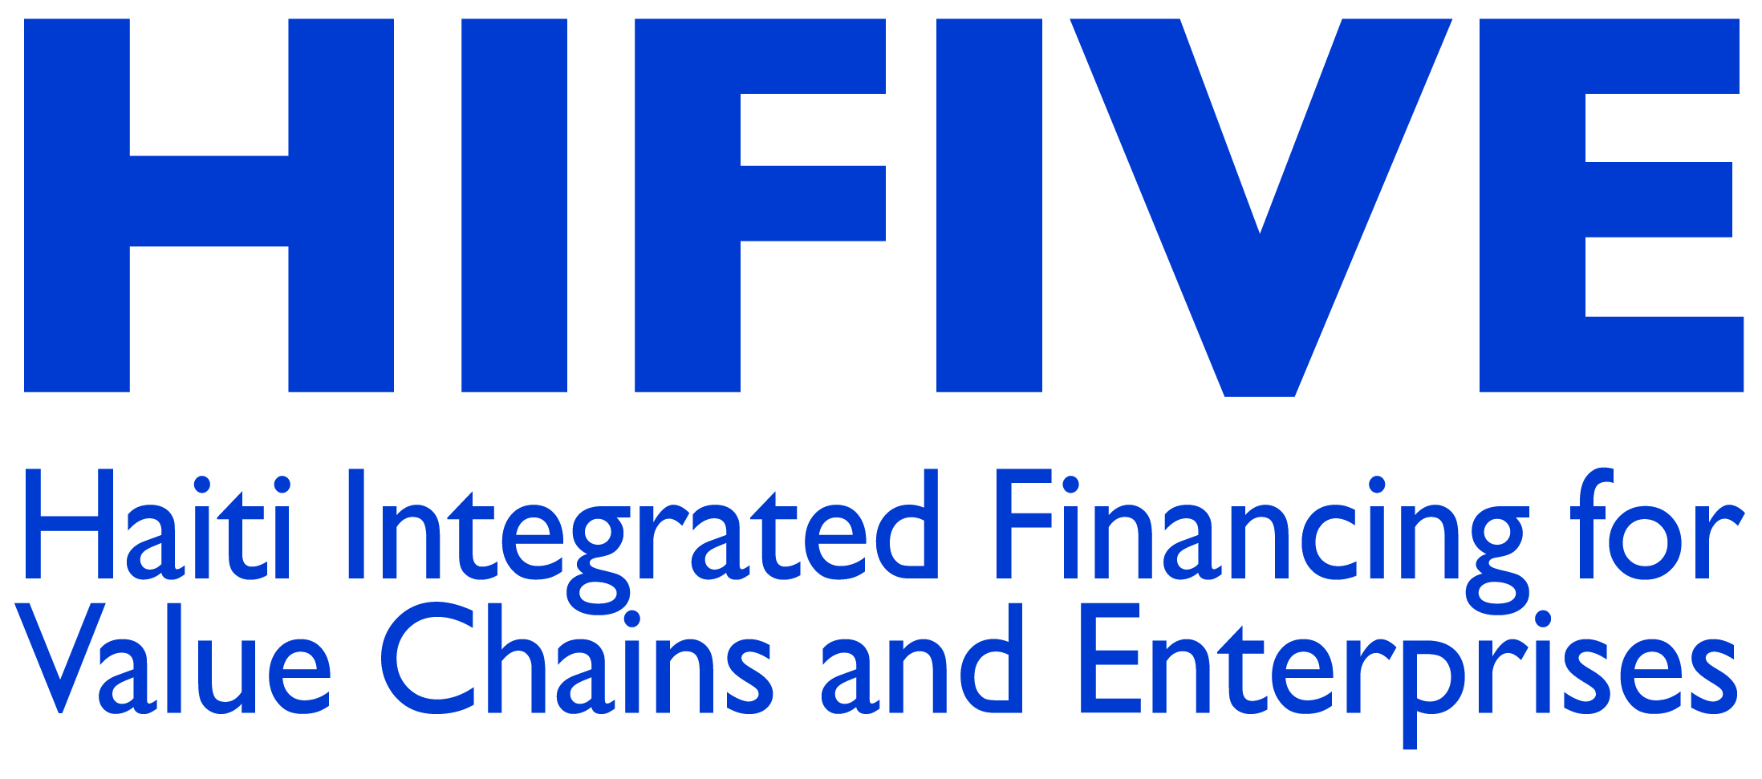

HIFIVE CATALYST FUND (HCF) Initial Proposal

Applicant Information

1. Activty name
2. Name of applicant institution/association
3. Address
4. Telephone, Fax, Email
5. Director of institution/association
6. Contact name for proposed activity
7. Length of proposed innovation (in months)
8. Dates of proposed activity
9. Cost-shared funds (by institution/ association or contributed by other donors/partners)
10. Total funds requested through HIFIVE
11. Total cost of activity

A) Background on the applicant organization. Briefly describe your organization’s activities.

B) Has your organization been working in microfinance, financial services, Information of communication technologies services or related activities in Haiti for at least two years?

Are your organizations a private Haitian organizations or private international for profit and non-profit organizations that are legally registered and recognized under the laws of Haiti?

C. Describe the activity

NB: Applications must be sent to HCFapplications@hifive.org.ht

