Colombia – Banca de las Oportunidades Project IV
Background
Banca de las Oportunidades has been funding WOCCU’s work in Colombia since 2008, which is now in the fourth iteration of this project. During the first project (2008 – 2010), WOCCU provided technical assistance to credit unions in nine under-developed regions of the country to strengthen institutional capital, improve governance, and expand savings and credit programs to low-income individuals.
WOCCU continued to strengthen the credit unions and helped expand access to finance for low-income populations during the second project (2011 – 2014), and by the end of the project credit union membership grew by 118,223 individuals, exceeding the initial project target by 118%. Banca decided to extend the project to 2016, increasing the goal to 200,000 people.
WOCCU pioneered the use of field officer banking in Colombia, which brought affordable financial services to more than 262,266 low-income, unbanked people, including 57% women, Afro-Colombians, indigenous groups, farmers, displaced people, micro small and medium enterprises (SMEs) and 59,171 children with savings accounts. During that project, WOCCU provided technical assistance and training to 31 credit unions, and 35 new microfinance products were developed successfully and implemented in rural and urban communities.
Under the third project (2013 – 2016), WOCCU introduced proven agricultural microcredit methodologies providing technical assistance and training to eight financial institutions (FIs) – four banks, two microfinance institutions (MFIs), and two credit unions, reaching rural smallholder’ farmers in more than 33 municipalities reaching the rural vulnerable population, most of them displaced, because of the insecurity caused by the illegal groups.
Current Project: (August 2016 – August 2019), $2 Million in funding
Under this latest project, WOCCU is working with Banca de las Oportunidades to: Perform market research to ensure that the technical assistance being delivered to financial institutions are meeting the needs of the low-income population affected by the closure of the border with Venezuela; Implementing financial methodologies and products for credit unions, commercial banks, microfinance institutions (MFIs), and insurance companies to better connect the adult population with financial institutions; Increasing delivery mechanisms for these financial services using correspondent agents, field agents, and mobile banking; Support financial literacy activities to improve savings-mobilization and increase knowledge about the financial services and products being offered; and Linking SMEs, entrepreneurs, and farmers with local organizations that can deliver training sessions on improving income generation activities.
The project’s goals are to:
- Reach 210,000 people, 100,000 of whom are individuals who have not been certified as members of the formal financial system.
- Educate 70% of the total population in basic financial literacy using massive strategies and campaigns.
- Conduct in-person financial literacy training for 5,000 individuals in urban areas.
- Deliver training sessions to village savings and loan association (VSLA) groups for 12,200 individuals in rural areas.
- Increase the number of field agents and correspondent agents in 18 municipalities.
- Link 2,000 individuals with organizations that can strengthen income generation activities.
To achieve these goals, WOCCU is working with financial institutions to reach rural areas through field agent and correspondent banking, while ensuring that these methodologies are sustainably implemented.
The project is helping financial institutions expand access to finance through new rural financing, savings, and insurance products, which are accompanied with financial literacy trainings. WOCCU is also helping credit unions and banks reduce barriers to financial inclusion by improving policies, procedures, strategies, and tools. Finally, the project is conducting on-site training, coaching and monitoring with financial institutions to ensure the use of financial services.
WOCCU is collaborating with these financial institutions to implement a rural financial services model, Semilla Rural, that will enable credit unions to provide financial products to the underserved. This approach, which was first piloted in Mexico and is now being implemented in Colombia and Haiti, combines different microfinance methodologies, such as village banking, community banks, individual microcredit, and village and savings loans.
Field agents go out to the villages and provide on-site transactions for clients, who otherwise would have to spend a tremendous amount of time and money to access these services at a physical location. Because field agents come from the community and have a higher-level of trust and pre-existing relationships, financial institutions can provide services to high-risk areas that have been affected by FARC and ELN activities.
Field agents are equipped with mobile devices that provide on-site services which will enable rural members to open accounts, make deposits, and conduct other financial transactions. These mobile devices also reduce operational risk, because these devices are linked to the financial institution’s banking software and allows transaction monitoring to be done in a more efficient manner.
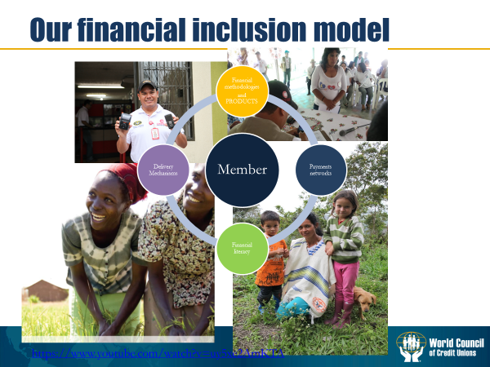
The use of mobile devices is also a part of WOCCU’s strategy to promote a branchless banking system, which also involves enabling microenterprises and businesses owners with mobile devices that allows them to conduct transactions, process withdrawals, accept payments, and process remittances. The project is currently working with two major commercial banks that offer these mobile banking services to help strengthen this branchless banking ecosystem.

